ADDING OFFENSE CODES/STATUTES/IBR CODES TO SPILLMAN

On the “Command:” line type “TBOFF” and hit enter
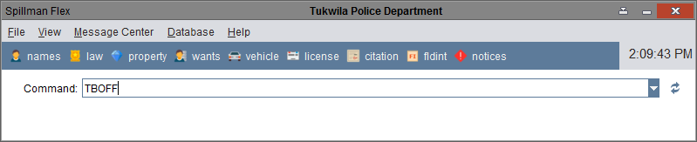

Click on “Add” to create a new record
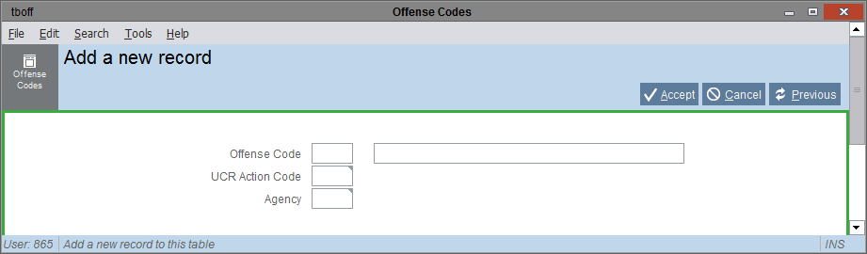

Enter the “Offense Code” (both code and literal), “UCR Action Code” (“0”) and “Agency” (“TPD”) then click on “Accept”
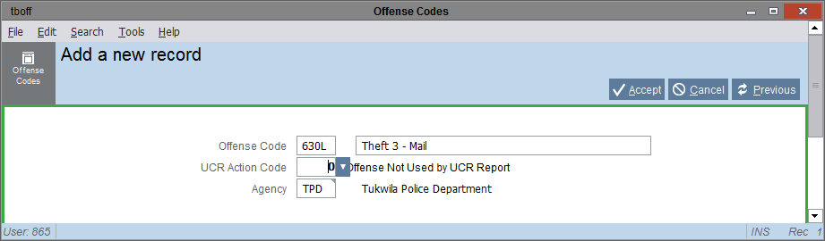

On the “Command:” line type “TBLAW” and hit enter
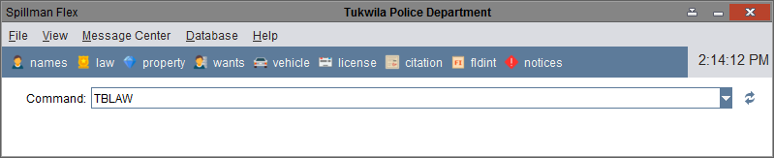

Click on “Add” to create a new record
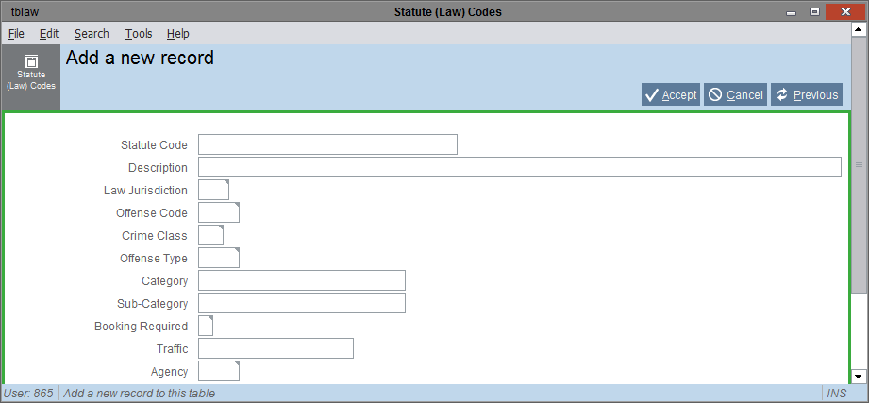

Enter “Statute Code” (corresponding RCW or TMC code), “Description” (literal description of the offense), “Law Jurisdiction” (“RCW” or “TMC”), “Offense Code”, “Offense Type” (“S”), and “Agency” (“TPD”) then click “Accept”
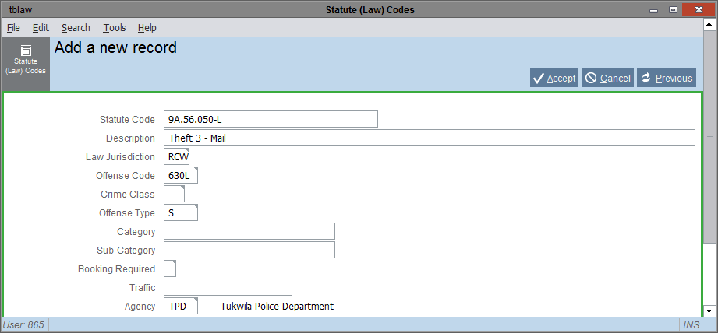

On the “Command:” line type “NIBRS” and hit enter
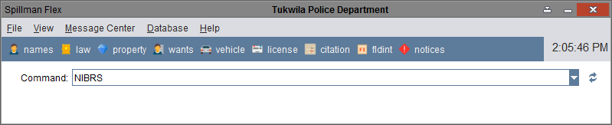

Go to “View” and click on “Show Tree Menus”

Click on “Code Table Menu”/”NIBRS Translation Menu”/”Offense Codes”
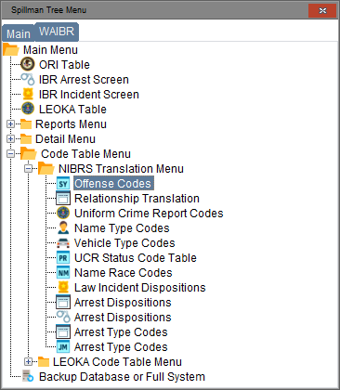
Click on “Code Table Menu”/”NIBRS Translation Menu”/”Offense Codes”
Search for the newly created “Offense Code”
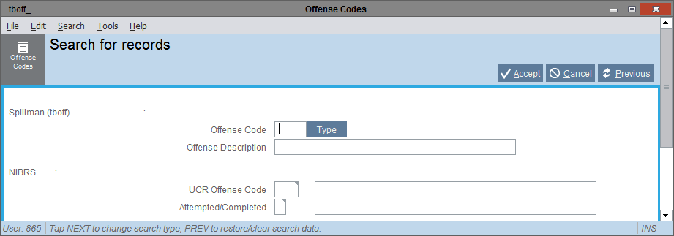
Enter the newly created “Offense Code” (i.e., 630L) and hit “Accept”
Click to “Modify” the record adding the appropriate “UCR Offense Code” and “Attempted/Completed”
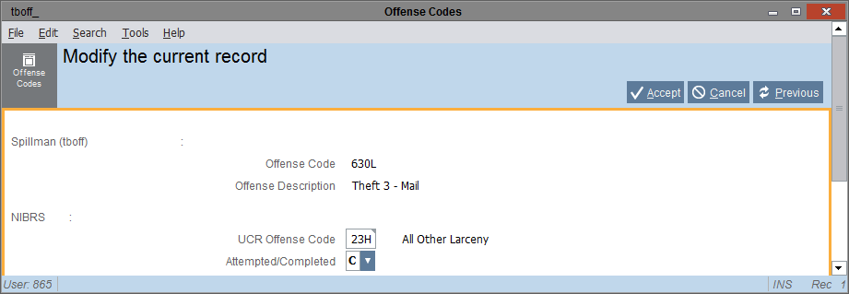
Add the connecting “UCR Offense Code” (i.e., “23H All Other Larceny”) and the “Attempted/Completed” (i.e., “A” or “C”), then hit “Accept”

